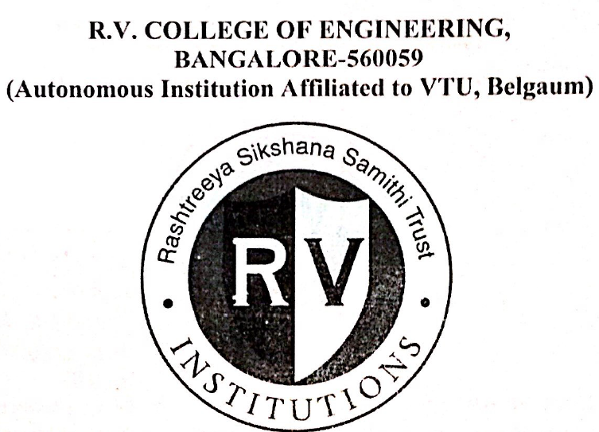

**BHOPAL GAS TRAGEDY**

**NAME:VANSHASH MAHAJAN**

**USN:1RV16CS172**

**Under the Guidance of**

**Dr. Harish K J**

**Department of CSE, R.V.C.E.,**

**Bengaluru - 560059**



***CERTIFICATE***

Certified that the self study work titled “BHOPAL GAS TRAGEDY” is carried out by **VANSHASH MAHAJAN(1RV16CS172)** who is bonafide student of R.V.College of Engineering, Banglore, in partial fulfillment for the award of degree of Bachelor of Engineering in Computer Science and Engineering of the Vishveswaraiah Technology University,Belagaun during year 2017-2018. It is certified that all corrections/suggestions indicated for the internal assesment have been incorporated in the report deposition in the department library. The Self study report has been incorporated in the report deposited in the department library. The Self Study report has been approved as it sayisfies the academic requirements in respect of the Self Study work prescribed by the institution for the said degree

Signature of staff incharge Marks Obtained

**OUTLINE**

* INTRODUCTION
* HOW DID IT STARTS
* AFFECTED AREA
* FACTORS INVOLVED FOR LEAK
* OVERALL GAS LEAK SUMMARY
* OTHER CAUSES
* CONTRIBUTION TO NEGLIGENCE
* ELIMINATION OF RISKS

**INTRODUCTION**

Bhopal gas tragedy, a disaster that happened by a Gas leak is considered as one of the world's worst Industrial catastrophes that occurred on the night of December 2–3, 1984 at the Union carbide India Limited (UCIL) Pesticide plant in Bhopal, Madhya Pradesh, India.

A leak of Methyl Isocyanate (MIC) gas and other chemicals from the plant resulted in the exposure of thousands of people. The toxic substance spread its way in and around the neighborhood located near the plant. That Resulted in a very high death toll. The official immediate death toll was 2,259 and the government of Madhya Pradesh has confirmed a total of 3,787 deaths related to the gas release.

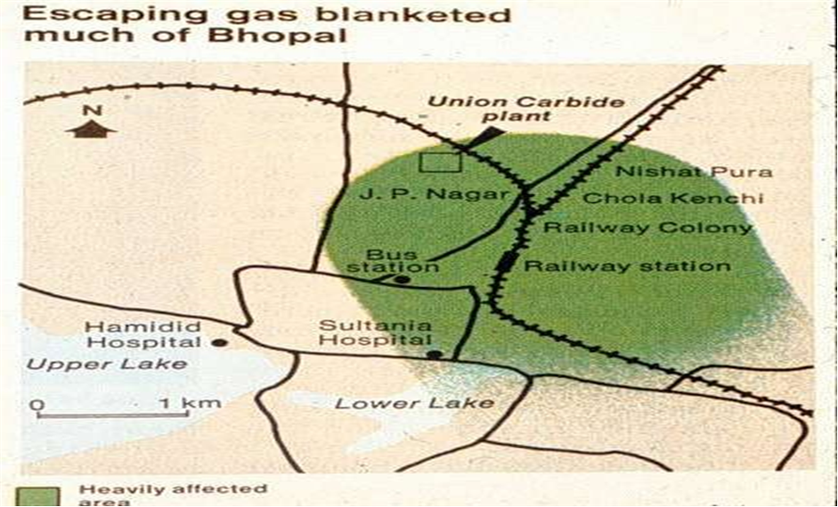

UNION CARBIDE INDIA LIMITED

UCIL was the Indian subsidiary

of Union Carbide Corporation (UCC), with Indian Government controlled banks and the Indian public holding a 49.1 percent stake. It started in 1969 at the northern state of India.

Phosgene, Monomethylamine, Methyl Isocyanate (MIC) and the pesticide Carbaryl, also known as Seven were manufactured here.

HOW DID IT START

To produce Pesticide Sevin with an intermediate methyl isocyanate (MIC).

It necessitated the start up of MIC production plant in 1979.

Following production continued ,ironically during the night of December 2–3, 1984, water entered Tank E610 containing 40 tons of MIC.

The resulting in exothermic reaction which increased the temperature inside the tank to over 200 C(392 F) and raised the pressure. About 30 metric tons of methyl isocyanate (MIC) escaped from the tank into the atmosphere, which got added to a weak wind which frequently changed direction, which in turn helped the gas to cover more area in a shorter period of time (about one hour).

This weak wind and the weak vertical turbulence caused a slow dilution of gas and thus allowed the poisonous gas to spread over considerable distances.

***WHAT FACTORS LEAD TO THE MAGNITUDE OF GAS LEAK??***

* Storing MIC in large tanks and filling beyond recommended levels.
* The flare tower and several vent gas scrubbers had been out of service for five months before the disaster.
* Failure of several safety systems .
* Also some safety systems being switched off to save money, including the MIC tank refrigeration the MIC was kept at 20 degrees Celsius, not the 4.5 degrees advised by the manual.
* There was only one manual back-up system, compared to a four-stage system used by union carbide plant of USA.
* Lack of skilled operators-No proper training was given to them.

***OVERALL VIEW OF THE GAS LEAK***

The scientific reason that caused the accident was that water entered the tank where about 40 cubic meters of MIC was stored.

As a result, the safety valve of the tank burst because of the increase in pressure.

It is presumed that between 20 and 30 tonnes of MIC were released during the hour that the leak took place.

The gas leaked from a 30 m high chimney and this height was not enough to reduce the effects of the discharge.

***OTHER CAUSES***

* Use of more dangerous pesticide manufacturing method for decreasing the

generation cost.

* Plant located very close to a densely populated area.
* Lack of skilled operators.
* Reduction of safety management.

***CONTRIBUTION TO NEGLIGENCE***

* UCIL didn’t maintained safety rules.......
* A pipe leaked? Don't replace it.
* MIC workers needed more training. They could do with less.
* The flare tower and the vent gas scrubber had been out of service for five months before the disaster.
* The steam boiler, intended to clean the pipes, was out of action for unknown reasons.

WHAT COULD HAD BEEN DONE TO AVOID THE DISASTER

* Supervisor could have been placed on night shifts and the readings and feedback of the Equipment could have been taken for every one hour.
* There should have been 4 stage back up system (union carbide plant of USA) instead of a one manual back up system.
* At regular intervals proper maintenance and servicing of Flare towers, pressure valves, gas scrubbers must have be made.
* Strict regulations and methods must have been used according to the manual.